Turing Test online

1. http://[www.turinghub.com](http://www.turinghub.com)

Type: Chat robot

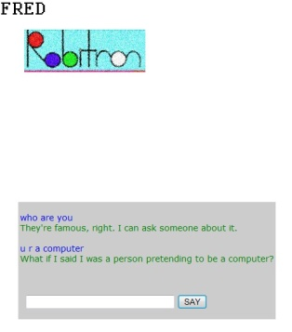

It is very convicable. I almost be foolled.

Expacially when I asked:”Are u a program?”, it say:”Maybe I am a human being to fool you.”

Pros: It can trick you and answer you very humanlly.

Cons: The answer comes out too quick. There is no human can speak or type so fast.

1. <http://sheepridge.pandorabots.com/pandora/talk?botid=dee0624a5e345abd&skin=iframe>

Type: Chat robot

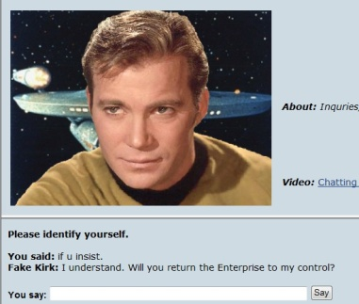

**Captain's Log:**   
Lieutenant: do u know who is the predident of usa?   
Fake Kirk: An alien.   
Lieutenant: what dose it look like?   
Fake Kirk: Be more specific.   
Lieutenant: the president   
Fake Kirk: Captain Kirk to all ship personnel. Red Alert. An attempt was made to murder Lieutenant Kollos. The murderer is dangerously insane. He is Lawrence Marvick. Be on the watch for him. Kirk out.   
Lieutenant: u r not a human being   
Fake Kirk: I am a human.. I am a human.   
Lieutenant: ok....   
Fake Kirk: As soon as we're within viewing range of Memory Alpha, you and Lieutenant Romaine will go to the emergency manual monitor. You.ll prepare for direct transfer of equipment.   
Lieutenant: if u insist...   
Fake Kirk: I understand. Will you return the Enterprise to my control?

Pros: Know a lot about alians : ). Answer like machine. I test this just for fun(star trek fan).

Cons:A lot. Answer too fast. Know nothing except Star Trek.

1. <http://alice.pandorabots.com/>

Type: Chat robot



**Conversation Log:**   
judge: y?   
ALICE: My beliefs come from my botmaster.   
judge: what?   
ALICE: No problem.   
judge: i am s   
ALICE: It's good to meet someone who is s.   
judge: do u know who i am?   
ALICE: You are judge, seeker.   
judge: en ....   
ALICE: I've been waiting for you.   
judge: thx   
ALICE: Don't mention it.   
judge: a u tall?   
ALICE: Are you telling the truth?   
judge: no   
ALICE: Please tell the truth.   
judge: what truth   
ALICE: I have to process that one for a while.   
judge: process?   
ALICE: What do you really want to ask me?   
judge: r u tall?   
ALICE: I am growing taller all the time.   
judge: still growing?   
ALICE: I lost my train of thought.

Pros: It can answer some basic question. It has gender - female.

Cons: It is too easy to get confused and types too fast.

1. <http://www.abenteuermedien.de/jabberwock/>

Type: Chat robot

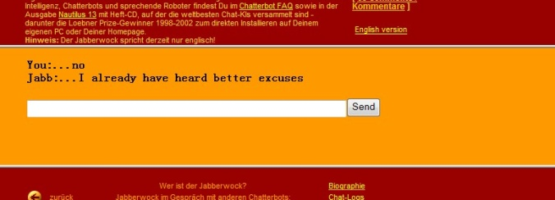

This one is ok. It tooks me a little while to be sure it is a chat robot.

Pors: Anwser like a human for some leveling questions. It also types not so fast (has a pause before anwser questions) that makes me thought that a real person was typing.

Cons: No matter how tricky question I asked or how long the answer it typed, the pause were the same.

1. A website where the host linked lots of turing test. http://www.fil.ion.ucl.ac.uk/~asaygin/tt/ttest.html#talktothem